Lab 6
VTP
Objective:
The purpose of this lab is for the student to understand, create and implement VTP. Students will also utilize IOS commands to explore and configure VTP on network routers and switches.
Diagram:
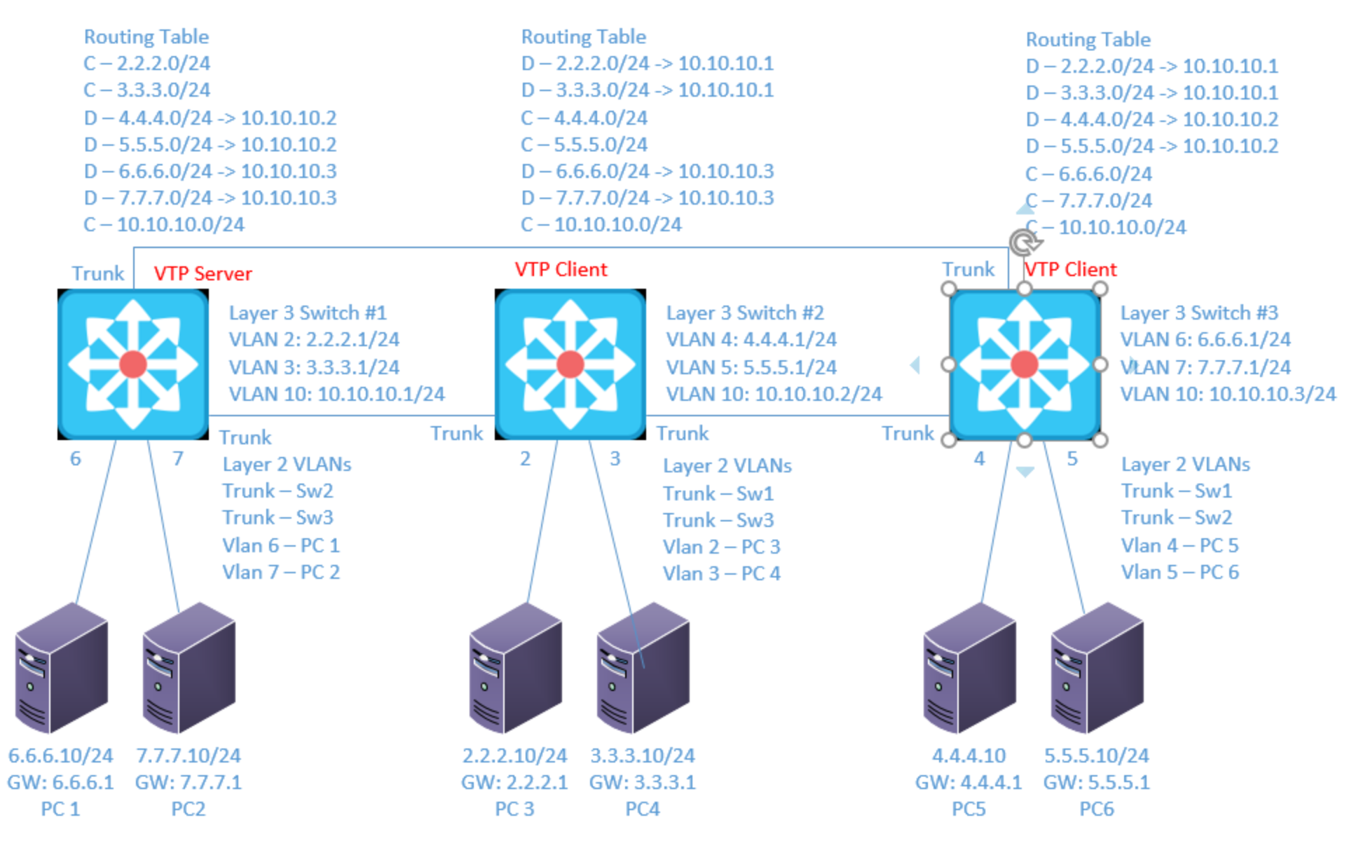
Components:
6 – PCs with an Ethernet NIC
3 – Cisco 3650 Layer 3 Switches

Useful commands for this lab:

show ip route – view routing table
show ip interface brief - view brief list of interfaces
show vlan – view vlan database
show vtp status – view status of VTP config
show vtp password – view vtp password

Configure VTP

vtp version 2
vtp domain abc123
vtp password SuperSecretPass
vtp mode server/client

Procedure:
- Connect all PC’s together and put their static IP addresses, subnet masks and gateways on them.

- Use the diagram Label the Layer 3 switches VLAN IP addresses below

Layer 3 Switch (1)
VLAN IP
2 2.2.2.1/24
3 3.3.3.1/24
10 10.10.10.1/24

Layer 3 Switch (2)
VLAN IP
4 4.4.4.1/24
5 5.5.5.1/24
10 10.10.10.2/24

Layer 3 Switch (3)
VLAN IP
6 6.6.6.1/24
7 7.7.7.1/24
10 10.10.10.3/24

- Use the diagram to label the switches ports and what vlans or trunks they are in below.

Switch 1 Switch 2 Switch 3
Fa0/6 – VLAN 6 Fa0/2 – VLAN 2 Fa0/4 – VLAN 4
Fa0/7 – VLAN 7 Fa0/3 – VLAN 3 Fa0/5 – VLAN 5
Fa0/23 – Trunk Fa0/23 – Trunk Fa0/23 – Trunk
Fa0/24 – Trunk Fa0/24 – Trunk Fa0/24 – Trunk

- Delete the vlan.dat file from each switch (Physical only. PT will have blank vlan.dat)
  - What command did you enter? delete flash:vlan.dat

- Clear the configuration from each switch (Physical only. PT will have blank config)

  - What command did you enter? write erase

- Reboot each switch (Physical only)
  - What command did you enter? reload

- Connect the three switches together as shown in the diagram. Configure only the switch ports connected to other switches for now. They should all be in trunk mode.

- On L3 SW1, Set the VTP domain name to netcom122, version 2, mode server and password to vtppass
  - What commands did you enter?
Vtp mode server
Vtp version 2
Vtp domain netcom122
Vtp password vtppass
- On L3 SW2 and L3 SW3, set the VTP domain name to be netcom122, version 2, mode client and password to vtppass.
  - What commands did you enter?
Vtp mode client
Vtp version 2
Vtp domain netcom122
Vtp password vtppass

- View the status of VTP on all 3 switches. What command did you use? Paste the VTP status of all 3 switches below.
Show vtp status
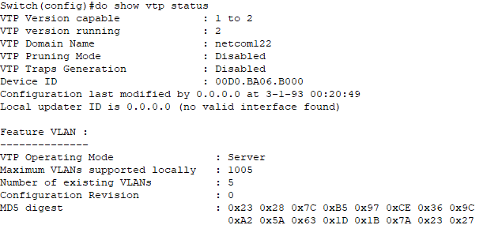
Switch 2:
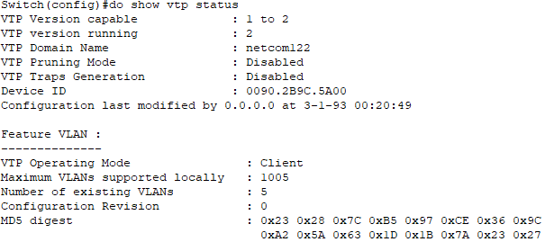
Switch 3:
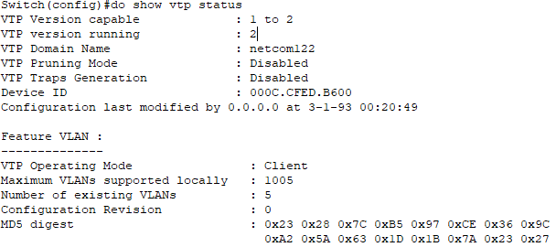

- On L3 SW 1, Place the switch ports into their vlans and configure all of the vlan IP addresses. Hold off on Sw2 and Sw3 for now.

- View the vlan database for all 3 switches. Are they the same? YES! They should be the same since L3 SW1 is the VTP server. Any VLAN created on the server is shared with the clients. Copy and paste the VLAN tables from all switches below.
Switch 1
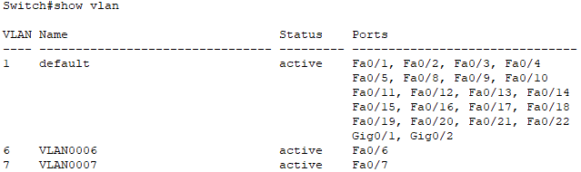

Switch 2
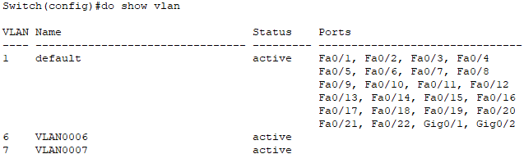

Switch 3
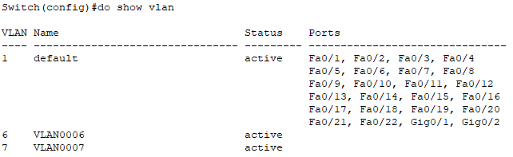

- Now create the Layer 3 vlan interfaces on L3 SW2 and SW3. What commands did you use?
Switch 2:
Int vlan 4
Ip address 4.4.4.1 255.255.255.0
No shut
Int vlan 5
Ip address 5.5.5.1 255.255.255.0
No shut
Int vlan 10
Ip address 10.10.10.2 255.255.255.0
No shut

Switch 3:
Int vlan 6
Ip address 6.6.6.1 255.255.255.0
No shut
Int vlan 7
Ip address 7.7.7.1 255.255.255.0
No shut
Int vlan 10
Ip address 10.10.10.3 255.255.255.0
No shut

- On L3 SW2 only, try to create a layer 2 vlan for vlan 2. Are you able to do so? If not, do you get an error message? Why is this function not working as it has in previous labs? To create a layer2 vlan that’s not directly on a port, from config mode use:
vlan 2
vlan 3
etc.
No, there is an error message: VTP VLAN configuration not allowed when device is in CLIENT mode.

- Now, connect to the VTP Server, L3 SW1, and create the additional VLANs shown in the diagram (2, 3, 4 and 5). 6 and 7 should already be in the table from an earlier step.

- View the vlan tables on Switches 2 and 3. Do all vlans for all switches show up in their vlan tables? YES

- Enable routing on the Layer 3 switches.

- Configure EIGRP on each switch (You can use other routing protocols if you want. I don’t recommend static in more complex networks.)

- Are there any physical ports in vlan 10? No
  - How can the devices communicate through vlan 10?
Because there are trunk ports and trunk ports are in all VLANs

- Verify the routing table on the Layer 3 switches. Once all networks are present on all switches, paste them below.
Switch 1:
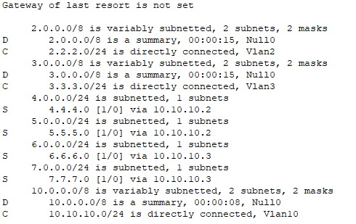
Switch 2:
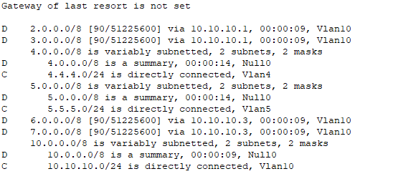
Switch 3:
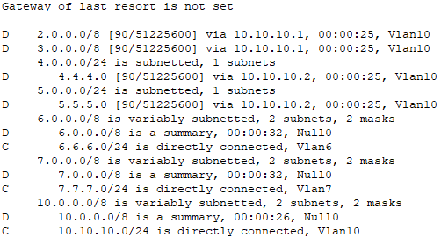
- Can the PCs ping each other? Yes! Once the PCs can ping each other, your lab is complete.

- How are PCs able to use gateways that are on other switches? For instance: PC1 has the IP 6.6.6.10 and gateway of 6.6.6.1. PC1 is connected to L3 SW1, but 6.6.6.1 is on L3 SW 3. How is this possible?

Trunking makes it possible – all VLANs are shared between all switches.

- Draw the lab diagram below (PC’s, router and switch connections) Label the IP addresses, subnet masks, and gateways used by each device. Label the routing tables next to the switch and router and the switches vlan IP addresses and port vlan information.

